Ormiston Academies Trust

Energy Management policy

Policy version control

|  |  |
| --- | --- |
| Policy type | OAT Mandatory |
| Author  In consultation with | James Miller |
| Approved by | OAT Exec June 2020 |
| Release date | June 2020 |
| Next release date | June 2023 |
| Description of changes | Completely rewritten – treat as new |

Contents

1. Executive Summary 3

2. UK Carbon Reduction Commitment 4

2.1. Political Context of the Climate Challenge 4

2.2. Streamlined Energy and Carbon Reporting 4

2.3. Trust Obligations 5

2.4. Trust Target 5

3. Energy Procurement 6

3.1. Progress Update 6

3.2. Available Supply Capacity 6

3.3. Procurement and Risk 7

3.4. Central Billing 7

3.5. Volume Tolerance 8

4. Reduction of Energy Consumption 8

4.3. Capital Investment 8

4.4. Cloud Computing 8

4.5. Energy Audit and Housekeeping 9

4.6. Targets 9

5. Generating Electricity 10

5.4. Capital Investment 11

5.5. Evidence Based Savings 11

Appendix 1 12

Electricity Price Inflation 12

Appendix 2 13

Savings 13

Appendix 3 14

Key legislation references 14

1. Executive Summary
   1. In 2016 Ormiston Academies Trust set three key objectives to change how it managed and used energy:

* **Maximize** the trust buying power by centrally procuring electricity and gas for the trust academies
* **Reduce** energy consumption through capital investment and a building user education programme
* **Generate** a proportion of the trust’s energy through investment in renewable energy technologies
  1. Since 2016 there have been seismic changes in how the climate challenges are viewed in the media and by students within the trust’s academies, this has been driven in part by Sir David Attenborough’s [Blue Planet](https://www.bbc.co.uk/programmes/p04tjbtx) programs, the [Youth Strike for Climate](https://ukscn.org/) inspired by Greta Thunberg and the [Extinction Rebellion](https://rebellion.earth/) protests. To move forward the trust has considered three core options:

Continue to buy green energy from EDF nuclear plants to meet carbon target and hope the saving made on electricity carbon reduction help deliver the saving required for gas. However, by 2025 the trust will need to budget an additional £1 million per annum to pay the academies’ utility bills.

building detailed monitoring and controls solution in to the eo portal will see eo consulting being able to offer its client a more detailed, robust and real time service which will have a price premium which to the client will be lost in any savings.

**Do Nothing**

Over the past three year the trust has invested in its estate, but the savings made have been offset by increases in others. Continuing this model will see money invested in energy management software but deliver no long-term savings. By 2025 the trust will need to budget an additional £1 million per annum to pay the academies’ utility bills.

**Monitor & Manage**

**Be Ambitious**

Focus on further reduction of energy consumption through capital investment, better day to day management of utilities, as well as generating a greater proportion of its own electricity with the aim of reducing consumption from the grid by over 50%, which by 2025 will realise a real term saving against the 2019-2020 budget.

* 1. Following an internal review of the options it has been agreed the trust needs to set out an ambitious policy which builds on its success and ensures the trust meets its responsibilities under the UK Government Carbon reduction commitment whilst leaving a real legacy for future generations.
  2. The policy moving forward focuses on **further reduction of energy consumption** and **generating a greater proportion of its own electricity** which will make the most of the current central contracts which are in place which have no minimum use restriction. As such the trust propose that by 2025 each of the trust academies will:
* consume 75% of the electricity they purchased from the National Grid in 2015 [per square metre]
* consume 50% of the gas they consumed in 2015 [per square metre]
* be self-generating 30% of the electricity they use
* reduce the trust carbon footprint by over 60% from the 2015 levels
* ensure the electricity not generated on site is procured from green sources
* have the facilities on site to charge electric vehicles
* no longer process their own energy invoices
  1. These ambitious targets not only help with addressing the trust carbon footprint, but they also support the financial challenges the trust faces as self-generating electricity reduces the cost of electricity by around 60% per kWh and energy efficiency projects such as LED lighting and cloud computing transfer reduced operational costs into capital investment. A detailed delivery plan for this policy will be developed into a bespoke plan and targets for each academy within the trust.

1. UK Carbon Reduction Commitment
   1. Political Context of the Climate Challenge
      1. The UK Climate Change Act 2008 is a landmark piece of environmental legislation, one that continues to attract interest and inspire action all round the world. It sets out a clear, legally binding framework to reduce greenhouse gas emissions and to ensure that the UK plays a part in avoiding dangerous climate change.
      2. The Climate Change Act 2008 set the country’s emission reduction targets. The ‘legally binding’ targets are a reduction of least 80% by 2050 (against the 1990 baseline).
      3. In 2017 the Department for Business, Energy and Industrial Strategy state that schools used around 13 terawatts of electricity and generated over 4.6 million tonnes of carbon. This equates to almost 1% of the UK carbon emissions and 20% of public sector emission based on the 2017 Clean Growth Strategy Data.
      4. An average secondary school produces between 200 and 300 tonnes of carbon per annum and a typical primary between 40 and 70 tonnes of carbon.
      5. 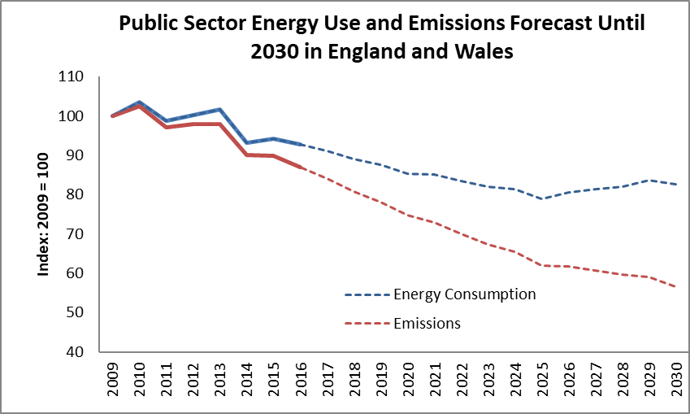Developing a strategy to impact the carbon dioxide emissions for England’s schools and academies would contribute to the UK government reducing its own carbon footprint.
      6. The Department for Business, Energy and Industrial Strategy is currently encouraging academies to use data from smart metering to help schools reduce their energy consumption by 15% and emissions by 40% by 2030.
   2. Streamlined Energy and Carbon Reporting
      1. The Companies (Directors’ Report) and Limited Liability Partnerships (Energy and Carbon Report) Regulations 2018 came into force on 1 April 2019 and apply to financial years starting on or after 1 April 2019. The legislation is aimed at tracking progress to the government’s carbon reduction targets.
      2. The regulations require academy trusts from their financial year 2019 – 2020 to report their greenhouse gas emissions under the [Streamlined Energy and Carbon Reporting](https://assets.publishing.service.gov.uk/government/uploads/system/uploads/attachment_data/file/850130/Env-reporting-guidance_inc_SECR_31March.pdf) requirements. Which require the trust to develop key performance indicators which:
      * Clearly reflect the scope of matter material to both your company and your stakeholders
      * Transparently review the quality of your disclosures
      * Provide clear conclusions on data quality and processes
      * Be conducted by a qualified, independent third-party reviewer
      * Meet the requirements of a recognised standard
      * Be easily understood and jargon free
   3. Trust Obligations
      1. Legally the government currently have no legislative tools to enforce the trust to reduce its carbon footprint however that may change in the coming years with new government legislation and the drive to a zero-carbon economy.
      2. In a political and social climate where carbon reduction is a major cause for concern for the trust, students, staff and parents, the trust has a moral obligation to make a change if it can. The trust knows change is possible through:
      * the work undertaken in the MAT loan pilot projects; academy carbon footprints can be easily reduced by 40-50% whilst also delivering long term saving to each academy’s operational budgets.
      * the collaboration with peers such as Brooke Weston Trust, Greenshaw Learning Trust and Ark Schools who are on similar carbon reduction journeys with the trust technical advisors.
      * experience, that monitoring of energy consumption alone does not reduce energy consumption.
      * supporting the site team at Ormiston Forge Academy to use consumption trends and energy audits to deliver overnight savings of 49,594kWh almost 10 percent of the academy electricity consumption resulting in an annual saving of over £5,000.
   4. Trust Target
      1. The reduction of the trust carbon footprint is inextricably linked to the consumption of energy from the grid or renewable sources which in turn has a day to day financial implication for the trust in that it has to pay for energy consumed from its general annual grant.
      2. If the trust puts in place an ambitious energy strategy to reduce its carbon footprint per metre squared of academy from the position it was in 2016 of 60% by 2025 then this will also bring a financial benefit for the trust to be releasing over £500,000 by 2025 and over £1,000,000 by 2030 against what the trust could be expected to pay for energy in those years based on energy price forecasts.
      3. This will be achieved by reducing the electricity from the grid by 75% and gas consumption by 50%, these are ambitious but realistic targets and will leave a real legacy for future generations of staff and students, as it will not only reduce the amount of carbon produced but also release over £1 million per annum into the trust budget by 2030 from the forecast spend on energy.

|  |  |  |  |  |  |  |
| --- | --- | --- | --- | --- | --- | --- |
| Year | **2020** | **2021** | **2022** | **2023** | **2024** | **2025** |
| Electricity Saving | 5% | 10% | 25% | 45% | 60% | 75% |
| Gas Saving | 5% | 10% | 20% | 30% | 40% | 50% |

1. Energy Procurement
   1. Progress Update
      1. Since the first Energy Policy was drafted in 2016 Ormiston Academies Trust has entered into three energy contracts:
      * the first started in 2016 and was designed to start harmonizing the multiple contracts which were in place and remove penalty clauses on consumption and give greater access to data.
      * the second contract started in September 2018; it saw an increase of 30% on electricity at fixed price to August 2020 and 18% increase on gas giving a fixed price to August 2022.
      * the third is an option to extend the second electricity contract to August 2021
      1. 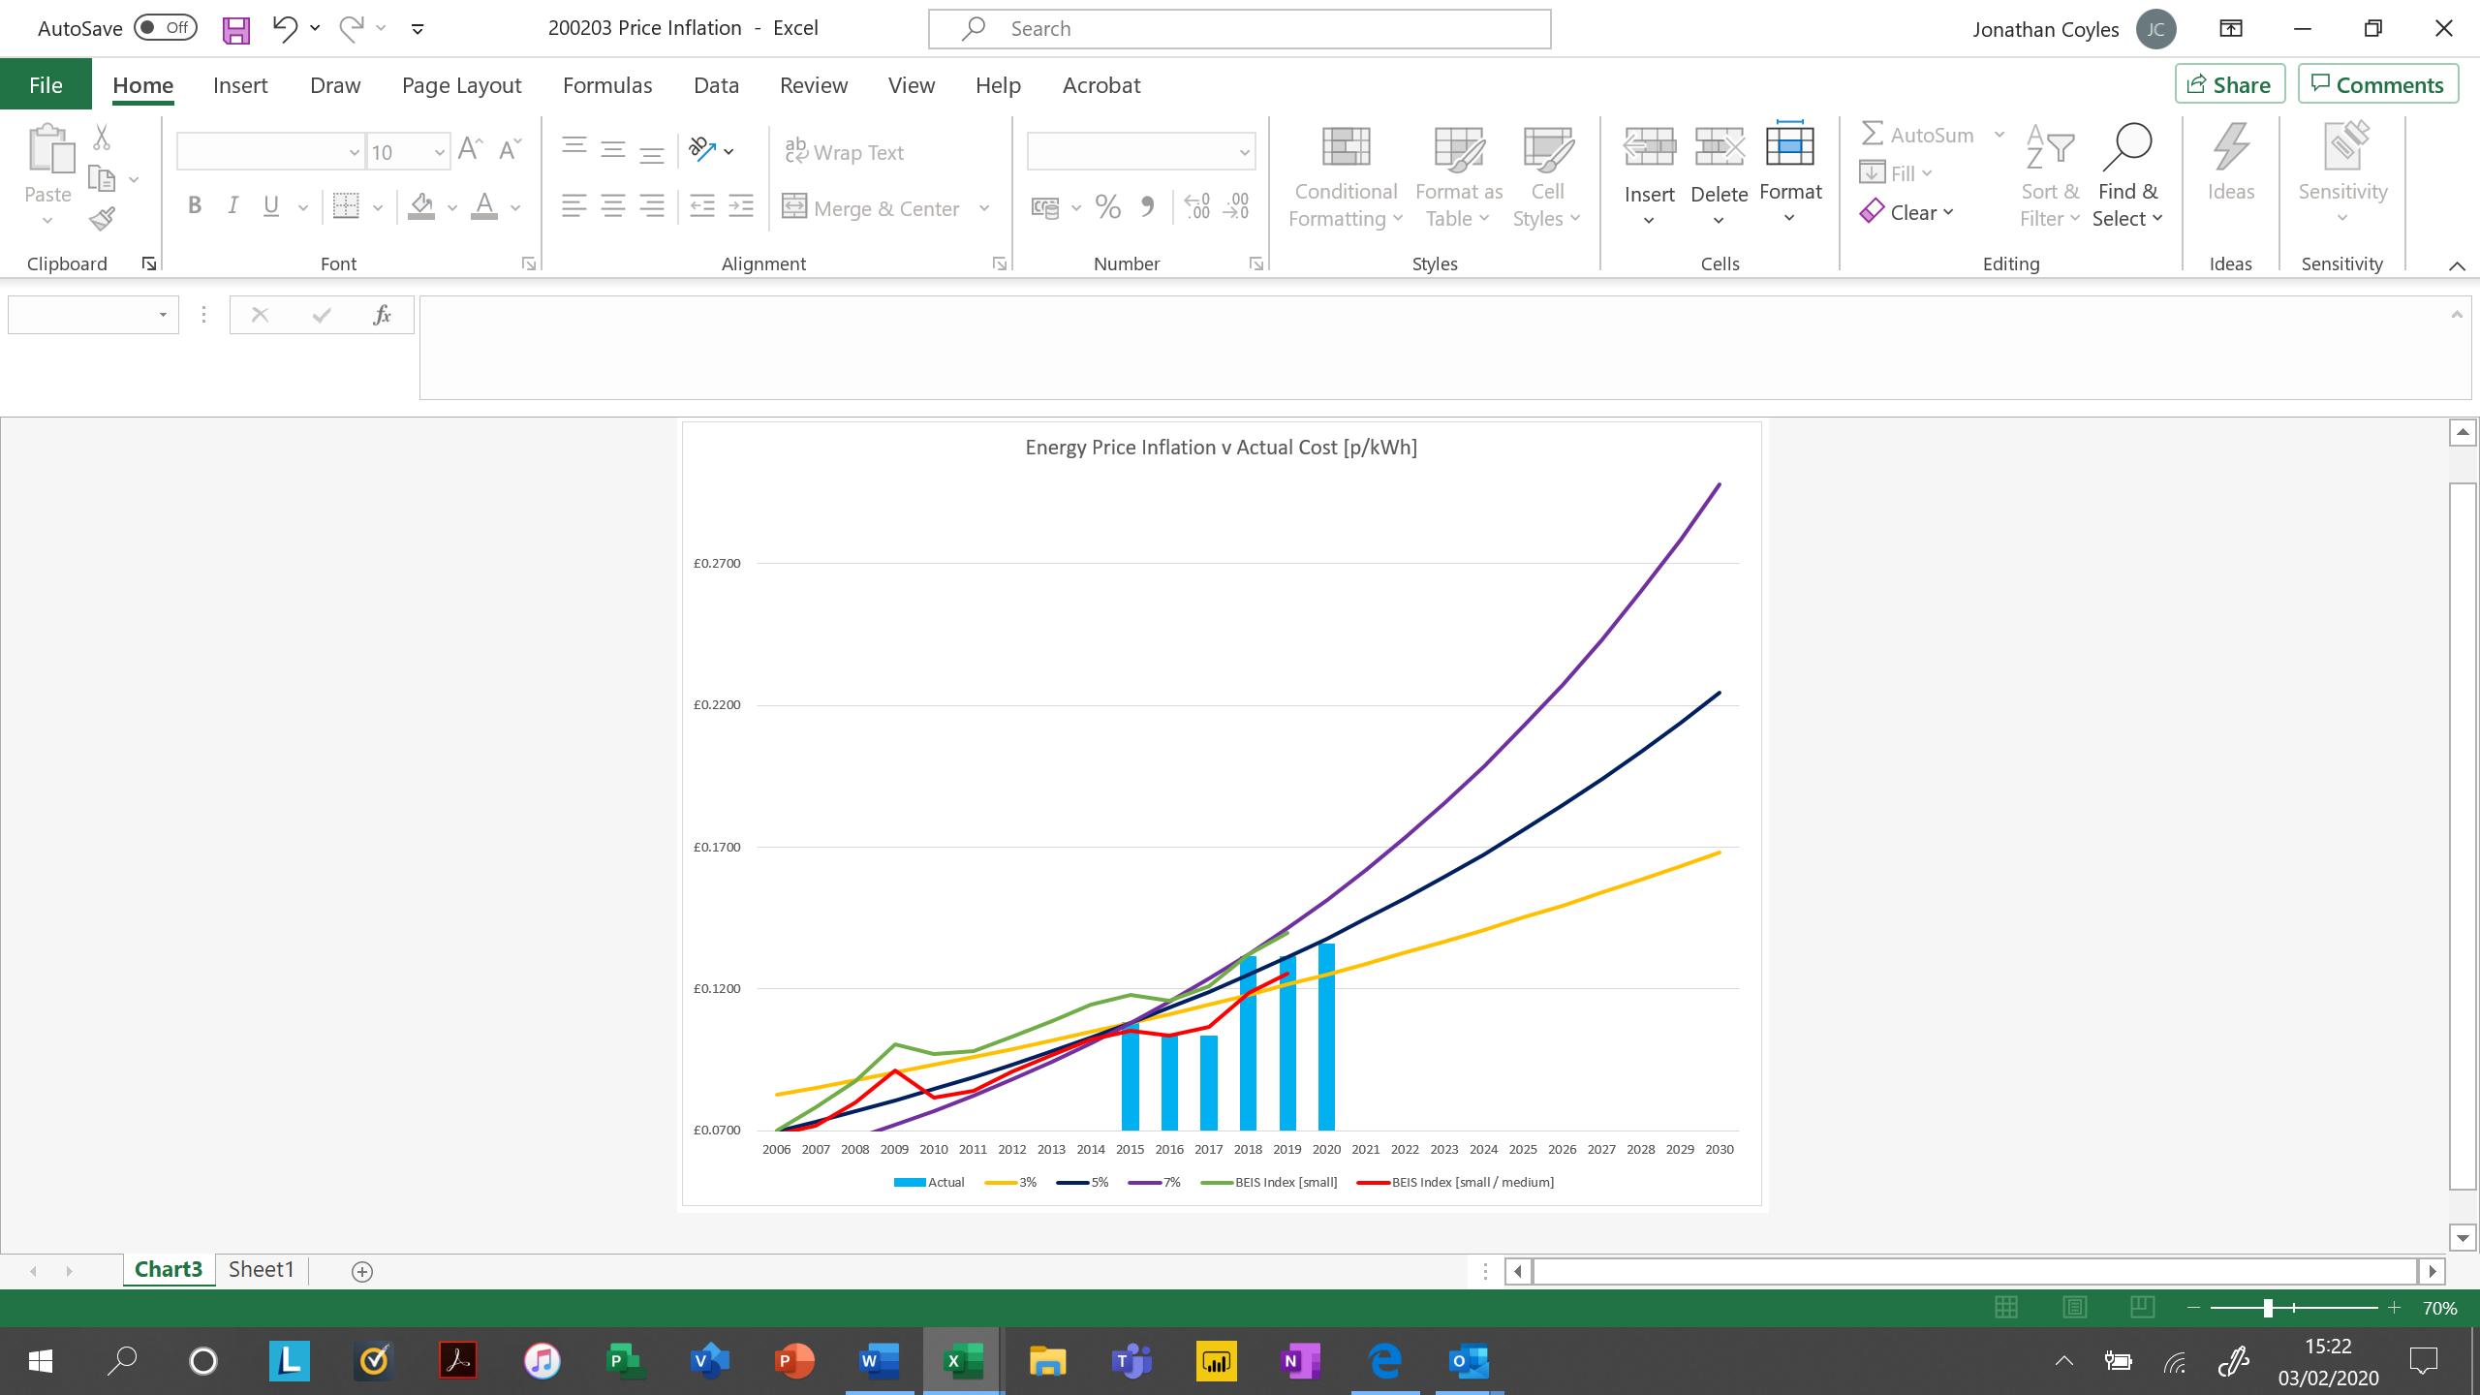What must be considered is that even though the trust has been exposed to a large increase in 2018 the year on year increase was in under 5% and below the government index for the majority of buildings of the size nature of the building the trust operates as defined in the government index.
      2. [Further details on how the trust energy costs compare to market conditions and inflationary assumptions can be found in appendix one]
   2. Available Supply Capacity
      1. Just like Goldilocks and her porridge, you want an Available Supply Capacity, that is just right. Set an ASC too low for your needs and you will be faced with excess capacity charges. Set an Available Supply Capacity too high for your needs and you will be faced with paying monthly for more Available Supply Capacity than you actually use.
      2. In order to determine the appropriate available supply capacity kVa for each MPAN, Ginger Energy undertake an annual review of each of the trusts academies’ requirements taking into consideration:
      * historic kVa demands
      * future demands such as expansion
      * LED relamping projects and other energy efficiency projects
      * self-generation plan
      1. In the 2019 – 2020 financial year the saving this delivered the trust exceeded £17,000 through reductions of:
      * £3,700 or 44% George Salter Academy
      * £3,200 or 43% Ormiston SWB Academy
      * £2,300 or 27% Shelfield Community Academy
      * £1,200 or 30% Cowes Enterprise College
      * £1,150 or 46% Tenbury High Ormiston Academy
      1. This process will continue to be completed annually by the team at Ginger Energy on behalf of the trust.
   3. Procurement and Risk
      1. The contract for electricity will expire on 31 August 2021, and the contract for gas expires on 31 August 2022.
      2. As a trust the policy will be to continue to market test the cost of energy every two to three years between now and 2025. The annual review will consider:
      * the best procurement route; be that a self-managed tender in line with the Academies Financial Handbook or the use of a framework such as Crown Commercial Services.
      * how much risk the trust is willing to take in relation to longer term price certainty compared to the opportunity to get a slightly lower price by taking shorter term contracts, where the price may go up as well as down.
   4. Central Billing
      1. Currently even though the trust has a central contract for electricity and gas each academy is billed separately with over 100 invoices being processed by the academies each month.
      2. The plan is that by August 2020 the trust will move to central billing, reducing the number of invoices to pay and process to two per month. The two invoices will be itemised by academy to ensure that there is transparency across the trust as to which academy has incurred which cost, but the process will save processing over 1,200 invoices per annum.
   5. Volume Tolerance
      1. Within the existing gas and electricity contracts which expire in August 2021 the trust have no minimum or maximum volumes to consume which provides real flexibility to become more effective consumers of electricity and gas.
      2. With the exception of the MAT Loans Pilot projects and the photovoltaic panels project at Stoke High the trust over the last three years has not maximised the opportunities to reduce energy consumption with no cost penalties.
      3. In the remaining eighteen months it is worth considering whether this flexibility is required in the future as reapplying some volume tolerance may return a better price as the risk to the suppliers may be seen to be reduced.

1. Reduction of Energy Consumption
   1. Having had success in reducing the annual energy consumption in eight of the trust’s academies by over 1,090,000 kWh through the investment of over £1.2 million in LED lighting it is clear there is an opportunity to substantially impact the trust energy bill and carbon footprint by further investment over the next five years. [See appendix two for more details]
   2. At the heart of the trust’s energy policy and detailed energy strategy for each academy there are three routes to reducing consumption which the trust will implement where appropriate before 2025:
      * Capital Investment
      * Cloud Computing
      * Energy Audit and Housekeeping
   3. Capital Investment
      1. Based on the data from the projects completed to date, LED lighting should in a secondary phase academy reduce the energy consumption, electricity bill and carbon footprint by over 20%, however it will require a capital investment of over £3 million to complete this across the trust in the next five years. This will be reviewed in the energy strategy on a case by case basis.
   4. Cloud Computing
      1. Approximately 30% of the trust electricity bill is linked to the running of servers and air conditioning supporting the core IT solutions within each academy. The trust is currently working to move more of its IT infrastructure to the cloud to ensure greater resilience of the systems as well as facilitate greater security of and access to data.
      2. As part of the detailed energy and IT strategies for the trust consideration should be given to the energy, carbon and cost reduction benefits of an IT Strategy based on cloud-based technologies.
   5. Energy Audit and Housekeeping
      1. 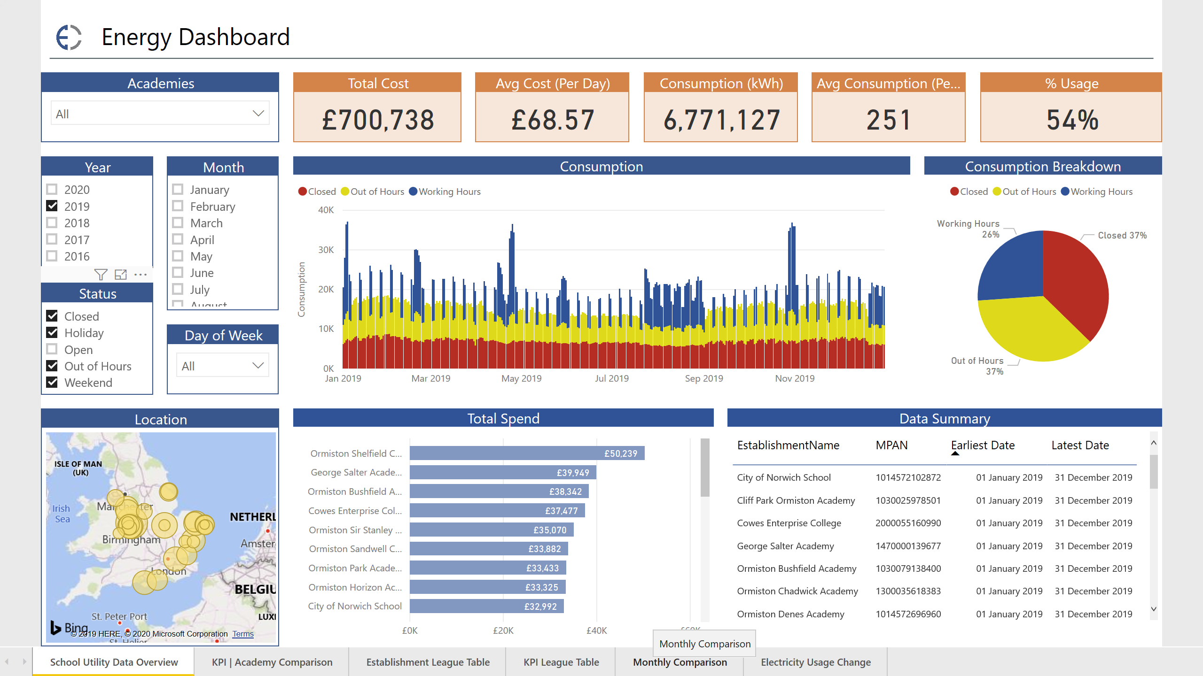From the data monitoring undertaken as part of the MAT Loans Pilot project the trust identified that 54% of the energy the trust consumes is when there are no students in the academies.
      2. Much of this consumption is due to IT infrastructure and cooling [addressed in section 4.2] however other elements are related to lack of understanding as to what equipment is running and at what time of day it is operational.
      3. The energy audit completed at Ormiston Forge Academy highlighted a range of challenges in relation to controls and management of plant and hot water systems within the academy which were addressed by the site team within the academy with minimum cost, and this has delivered overnight savings of 49,594kWh (almost 10 percent of the academy electricity consumption), resulting in an annual saving of over £5,000.
      4. The plan in the next two years is to undertake detailed energy audits of all of the trust academies to support each academy to reduce their carbon footprint without incurring substantial capital investments.
   6. Targets
      1. Each of the academies within the trust will require support and direction in reducing their energy consumption and carbon footprint. By developing a set of key performance indicators and a bespoke dashboard, the trust will be able to set each academy a clear target.
      2. The key performance indicators will also be the benchmarks against which the trust will report on when completing its Streamlined Energy and Carbon Reporting. The trust’s 15 key performance indicators for the management of energy are:

|  |  |  |  |
| --- | --- | --- | --- |
| Money | cost per pupil |  | For each of these KPI the trust policy will be to reduce consumption from the 2016 levels by:  5% by December 2020  and  10% by August 2021  where the energy consumption per meter squared is above 35kWh  where the consumption is below 35kWh individual targets will be agreed |
| Coins | cost per metre squared |  |
| Group | kWh per pupil |  |
| Schoolhouse | kWh per metre squared |  |
| Sun | percentage of energy used generated from renewables |  |
| Lecturer | kWh per metre squared | open |  |
| Moon and stars | kWh per metre squared | closed |  |
| Sport balls | kWh per metre squared | out of hours |  |
| Maze | kWh per metre squared | weekends |  |
| Beach umbrella | kWh per metre squared | holiday |  |
| Lecturer | percentage of energy used | open |  |
| Moon and stars | percentage of energy used | closed |  |
| Sport balls | percentage of energy used | out of hours |  |
| Maze | percentage of energy used | weekends |  |
| Beach umbrella | percentage of energy used | holiday |  |

1. Generating Electricity
   1. The trust now has fifteen academies which have the ability to generate their own electricity; three times as many as it had in 2016 when the policy was first developed. Some, such as Ormiston Forge Academy, City of Norwich School and Cliff Park Ormiston Academy have the ability to generate almost 100,000kWh per annum which is over 12% of the energy for each academy.
   2. It is clear from the electricity consumption patterns the trust has the ability to generate and use 30% of its own electricity without the need to export electricity to the grid. A greater percentage of the trust energy could be generated but this would need to be complemented with battery storage for when generation exceeds demand on summer weekends or in the summer holiday period.
   3. As a trust, generating electricity does not make the academies more energy efficient, however what it does do is buy energy at a fixed price for the warrantied life of the panels [usually 20 to 25 years]. The electricity purchased from the photovoltaic [PV] arrays installed as part of the MAT Loans Pilot project will cost around 4.8p/kWh over the warrantied life of the panels. [See appendix two for more details]
   4. Capital Investment
      1. Each academy could benefit [including those which already have PV panels] from the installation of PV panels enabling them to generate up to 30% of their own electricity. The plan is to install a 200kWp array on each secondary academy and a 30kWp array on each primary academy where possible by 2025.
      2. Based on a benchmark cost of £850 per kWp to deliver a 200kWp array on each secondary academy and a 30kWp on each primary academy it would require an investment £4.5 million which would deliver a saving over the 25 years of the warrantied life of the PV Panels of over £35 million based on 5% electricity price inflation, which releases £30 million into teaching and learning or the trust building maintenance programme over the next 25 years.
      3. There are a number of private sector funders such and social enterprises which will fund photovoltaics and LED lighting in schools such as Less is More Capital, who have offered to fund any trust wide programme.
   5. Evidence Based Savings
      1. In 2019 Ormiston Academies Trust generated enough energy from photovoltaics to run one secondary academy and all its primary academies saving over £90,000.
      2. If over the next five years, the trust was to install photovoltaic to give each secondary academy a generation capacity of 200kWp and each primary 30kWp generation capacity the trust would have in place enough capacity to generate over 6 million kWh of electricity.
      3. The 6 million kWh is enough to run a third of the trusts academies and would be worth £790,000 based on current electricity prices.

Appendix 1

Electricity Price Inflation

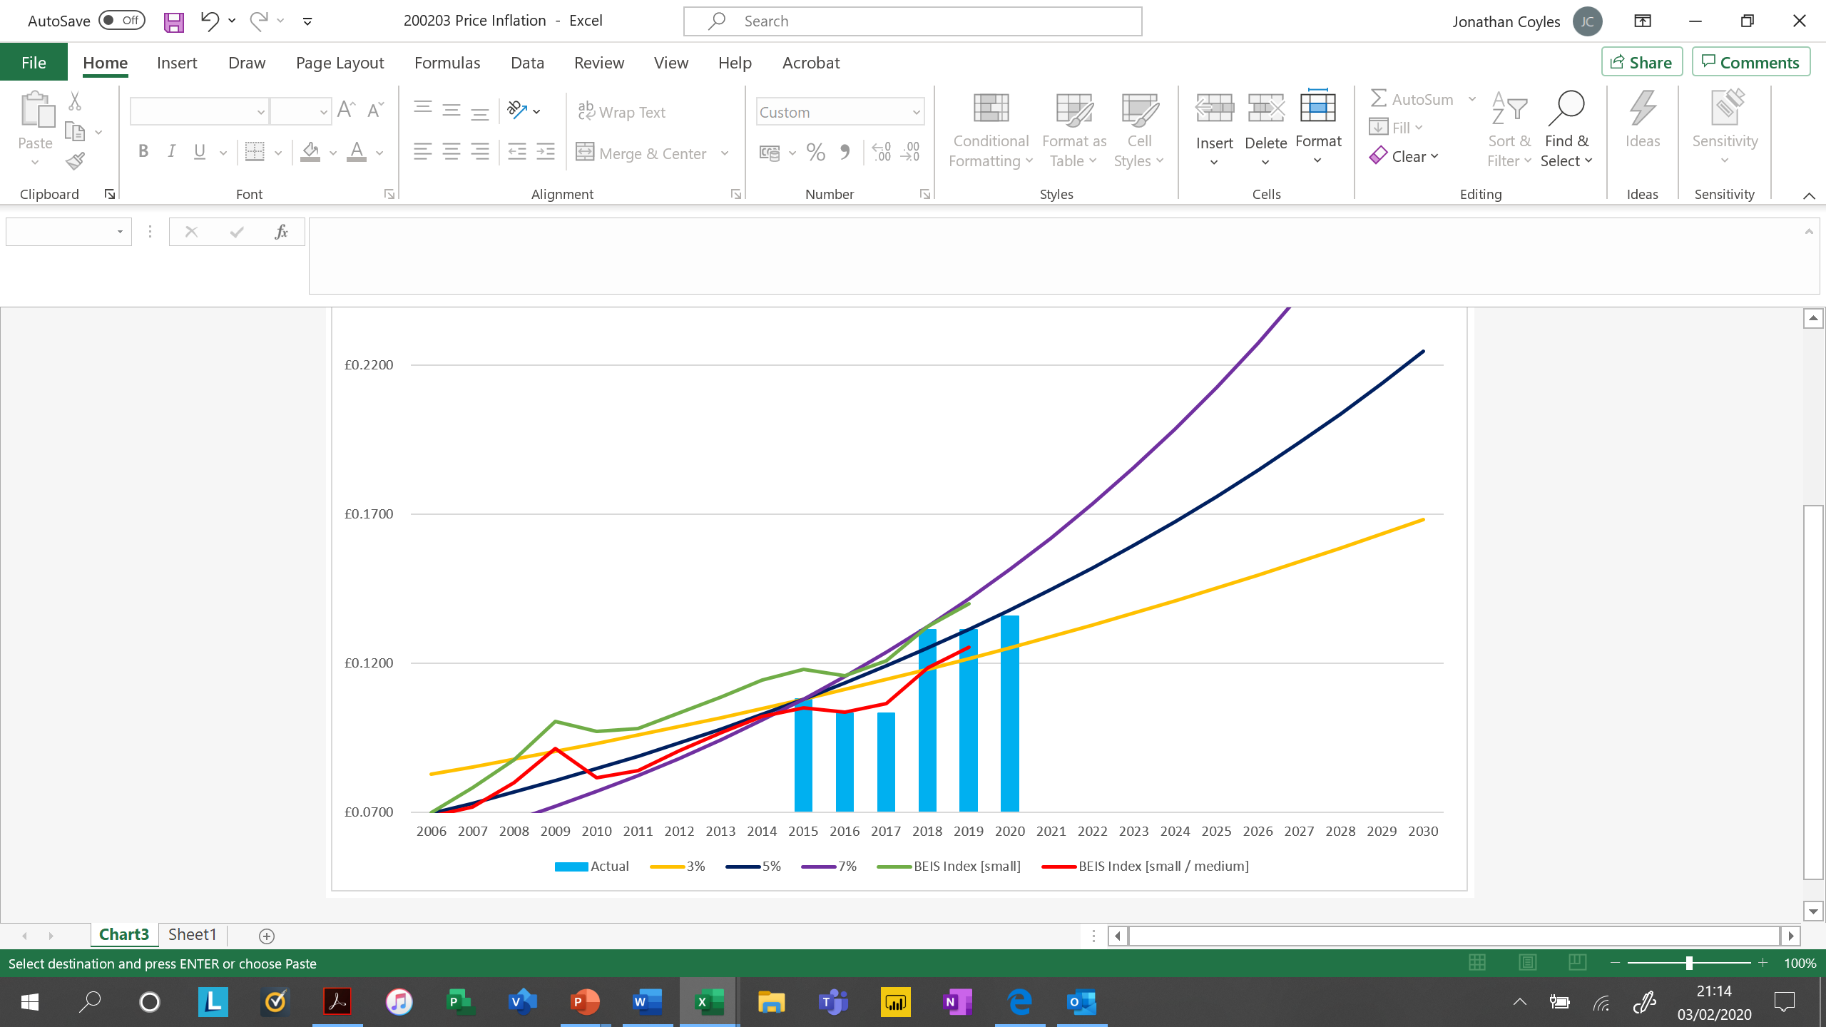

|  |  |  |  |  |  |  |
| --- | --- | --- | --- | --- | --- | --- |
| Year | Actual | 3% | 5% | 7% | BEIS Index [small] | BEIS Index [small / medium] |
| 2006 |  | £0.08277 | £0.06962 | £0.05874 | £0.07002 | £0.06866 |
| 2007 |  | £0.08526 | £0.07310 | £0.06286 | £0.07834 | £0.07189 |
| 2008 |  | £0.08781 | £0.07675 | £0.06726 | £0.08766 | £0.08005 |
| 2009 |  | £0.09045 | £0.08059 | £0.07196 | £0.10039 | £0.09136 |
| 2010 |  | £0.09316 | £0.08462 | £0.07700 | £0.09716 | £0.08160 |
| 2011 |  | £0.09596 | £0.08885 | £0.08239 | £0.09810 | £0.08398 |
| 2012 |  | £0.09884 | £0.09329 | £0.08816 | £0.10327 | £0.09079 |
| 2013 |  | £0.10180 | £0.09796 | £0.09433 | £0.10869 | £0.09679 |
| 2014 |  | £0.10485 | £0.10286 | £0.10093 | £0.11442 | £0.10225 |
| 2015 | £0.1080 | £0.10800 | £0.10800 | £0.10800 | £0.11790 | £0.10513 |
| 2016 | £0.1033 | £0.11124 | £0.11340 | £0.11556 | £0.11577 | £0.10363 |
| 2017 | £0.1033 | £0.11458 | £0.11907 | £0.12365 | £0.12084 | £0.10648 |
| 2018 | £0.1313 | £0.11801 | £0.12502 | £0.13230 | £0.13242 | £0.11844 |
| 2019 | £0.1313 | £0.12155 | £0.13127 | £0.14157 | £0.13987 | £0.12532 |
| 2020 | £0.1358 | £0.12520 | £0.13784 | £0.15148 |  |  |
| 2021 |  | £0.12896 | £0.14473 | £0.16208 |  |  |
| 2022 |  | £0.13283 | £0.15197 | £0.17342 |  |  |
| 2023 |  | £0.13681 | £0.15957 | £0.18556 |  |  |
| 2024 |  | £0.14092 | £0.16754 | £0.19855 |  |  |
| 2025 |  | £0.14514 | £0.17592 | £0.21245 |  |  |
| 2026 |  | £0.14950 | £0.18472 | £0.22732 |  |  |
| 2027 |  | £0.15398 | £0.19395 | £0.24324 |  |  |
| 2028 |  | £0.15860 | £0.20365 | £0.26026 |  |  |
| 2029 |  | £0.16336 | £0.21383 | £0.27848 |  |  |
| 2030 |  | £0.16826 | £0.22452 | £0.29798 |  |  |

**Note:**

BEIS Index [small] consumes between 20,000 kWh and 499,000 kWh per annum

BEIS Index [small / medium] consumes between 499,000 kWh and 1,999,000 kWh per annum

Appendix 2

Savings

|  |  |  |  |  |  |  |  |  |  |  |
| --- | --- | --- | --- | --- | --- | --- | --- | --- | --- | --- |
| Academy | | Norwich | Chadwick | Denes | Forge | Herman | Tenbury | Cliff Park | Ilkeston | Totals |
| Consumption | **2016** | 785,060 | 503,510 | 439,350 | 760,380 | 73,360 | 209,029 | 452,870 | 650,160 | **3,873,719** |
| **2017** | 668,710 | 503,510 | 439,350 | 738,290 | 74,020 | 196,630 | 430,440 | 625,500 | **3,676,450** |
| **2018** | 583,240 | 410,070 | 361,260 | 593,140 | 67,000 | 160,420 | 390,050 | 484,980 | **3,050,160** |
| **2019** | 574,713 | 348,959 | 294,490 | 483,989 | 59,457 | 146,852 | 391,543 | 483,244 | **2,783,247** |
| Electricity  p/kWh | | 0.131291 | £0.139273 | £0.133086 | £ 0.133684 | £ 0.132312 | £ 0.134152 | £ 0.135456 | £ 0.133453 |  |
| Saving 2016 v 2019 | **kWh Total** | 210,347 | 154,551 | 144,860 | 276,391 | 13,903 | 62,177 | 61,327 | 166,916 | **1,090,472** |
| **kWh PV** | 62,375 | 23,832 | 52,519 | 104,263 | 8,596 | 28,175 | - | - | **279,760** |
| **kWh LED** | 147,972 | 130,719 | 92,341 | 172,128 | 5,307 | 34,002 | 61,327 | 166,916 | **810,712** |
| **% Total** | 26.79% | 30.69% | 32.97% | 36.35% | 18.95% | 29.75% | 13.54% | 25.67% | **28.15%** |
| **% PV** | 7.95% | 4.73% | 11.95% | 13.71% | 11.72% | 13.48% | 0.00% | 0.00% | **7.22%** |
| **% LED** | 18.85% | 25.96% | 21.02% | 22.64% | 7.23% | 16.27% | 13.54% | 25.67% | **20.93%** |
| **£** | **£ 27,617** | **£ 21,525** | **£ 19,279** | **£ 36,949** | **£ 1,840** | **£ 8,341** | **£ 8,307** | **£ 22,275** | **£ 146,133** |

Appendix 3

Key legislation references

[Climate Change Act (2008)](http://www.legislation.gov.uk/ukpga/2008/27/contents) underpins the vast majority of the UK Government [Net Zero](https://www.theccc.org.uk/publication/net-zero-the-uks-contribution-to-stopping-global-warming/) approach to reducing carbon emissions, this legislation was amended last year to commit the UK to being carbon neutral by 2050 at the latest, and has implications for public sector buildings. For schools it is also probably worth referencing the [Academies Act (2010)](http://www.legislation.gov.uk/ukpga/2010/32/contents) as this refers to academies having charitable status and owning most of their own buildings.

Academies will need to report their greenhouse gas emissions under the [Streamlined Energy and Carbon Reporting](https://www.gov.uk/government/publications/environmental-reporting-guidelines-including-mandatory-greenhouse-gas-emissions-reporting-guidance) requirements, depending on their size.

[Greening Government commitments](https://www.gov.uk/government/publications/greening-government-commitments-2016-to-2020/greening-government-commitments-2016-to-2020), commit all public sector buildings to reduce their carbon emissions by a specific percentage. Although these targets are not mandatory they do inform the Government approach to public sector energy efficiency, and are a key part of the [Clean Growth Strategy](https://www.gov.uk/government/publications/clean-growth-strategy).

Another key reference for each academy is that over [half of local authorities have declared a climate emergency](https://www.climateemergency.uk/blog/list-of-councils/) and are working with their local communities to address this. Although academies are no longer local authority controlled, their reductions can contribute towards the local authority meeting their Greening Government commitments, so it might act as a way to work closer with the local authority on carbon reduction projects and funding options, if the academy is interested in doing so.